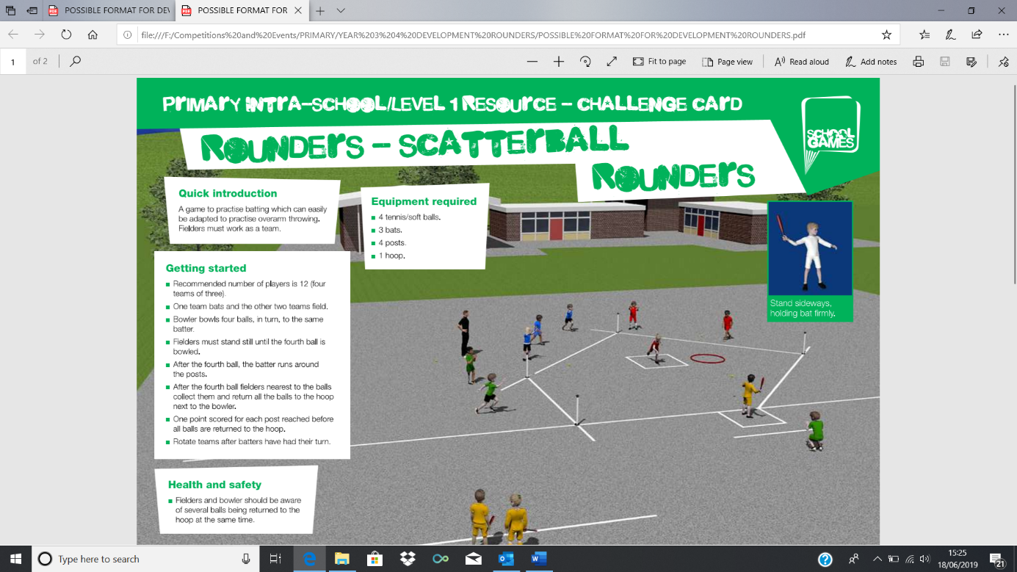

YEAR 3 AND 4 DEVELOPMENT ROUNDERS

The Year 3 and 4 Development Rounders is the SSFT adaptation of ‘Scatterball’ which we have changed slightly to incorporate all 6 players, with 2 teams on each pitch.

How to play:

All players will bat and field in turn and work as a team. The bowler will bowl 4 balls, in turn, to the same batter. Fielders must stand still (out on the pitch) until the 4th ball is bowled. After the 4th ball is bowled, the batter runs around the 4 posts. The Batter must take the bat with them whilst they run and must touch 4th post with the bat if they reach it. The Batter may only run around the circuit of 4 posts once, with a maximum of 4 points per player, per innings. After the 4th ball is bowled, the fielders retrieve the balls and places them in the bucket/hoop beside the bowler (no more than 1 ball per fielder can be put in the hoop/bucket). Fielders can pass the ball to a team mate.

One point is scored for each post that the batter reaches before all balls are returned to the bucket/hoop. After all 6 batters have had their turn, the teams change over. There will be 2 innings, so the above will be repeated a 2nd time.

The Batters will have the choice of using a plastic bat or a proper rounders bat.

We will be using tennis balls on each pitch.

If a Fielder catches a ball straight from the batters bat, the batting team lose 1 point.

All Fielders must watch the ball at all times and must not obstruct the path of the Runner.

SFT/Leaders will be the Bowler on each pitch on the day and will signal when all 4 balls have been placed in the bucket.