
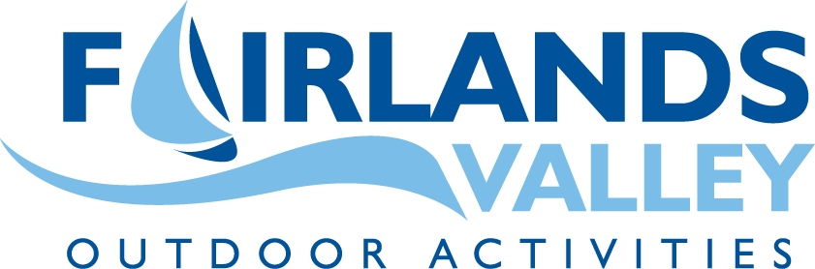


Primary School Bell Boat Festival 2018
This Festival is open to all Stevenage Sporting Futures Partner schools and will take place on Wednesday the 23rd of May at Fairlands Valley Lakes. This event is all day and will include some other activities. Teams will need to arrive for registration by 08:45am with the first race-taking place at 09:15am. We aim to finish the day by 3pm.
Places are limited to 22 teams and therefore schools may only enter 1 team of 10 children (*Note the number in a team as the boats are smaller). If we have spaces nearer the time to fill, we will offer these out and it will be first come first served for a 2nd team.
Each team must be made up of pupils from years 3&4 and at least five members of each team must be girls. There will be a small charge of £50 per team required.
NB: Schools will be invoiced and Cheques must now be made payable to the Stevenage Sporting Futures Team please.

From the races in the morning, the fastest teams will go through to the quarter finals or semi finals (time and weather dependant) in the afternoon.
A programme of activities throughout the day will be provided when teams are not competing. All of the activities will only take a maximum of 10 pupils so please do not bring extra children and expect them to participate. This is because of the rules and regulations set out by the SLL team’s governing bodies and AALA.

We ask that each group of 10 has at least one adult with them at all times and that each school has a nominated group leader who we have contact details for. They will be our point of contact to which all paperwork will be directed.

*We would like all teams to remain until the end please for the presentations, as in past years there are not many spectators to congratulate the winners which is a real shame. If all teams can congregate at Race control at the end we would be very grateful to make this a really special occasion for the Winners!*
A certificate will also be presented to a team that shows good Sportsmanship and effort throughout the day.

If you wish to take part in this event, please fill in the attached form and return it as soon as possible together with your cheque made payable to the Stevenage Sporting Futures Team:
FAO: Julia Burrows
‘Bell Boat’
SSFT
Barnwell Community Leisure Centre
Barnwell Upper Campus
Barnwell
Stevenage
Herts.
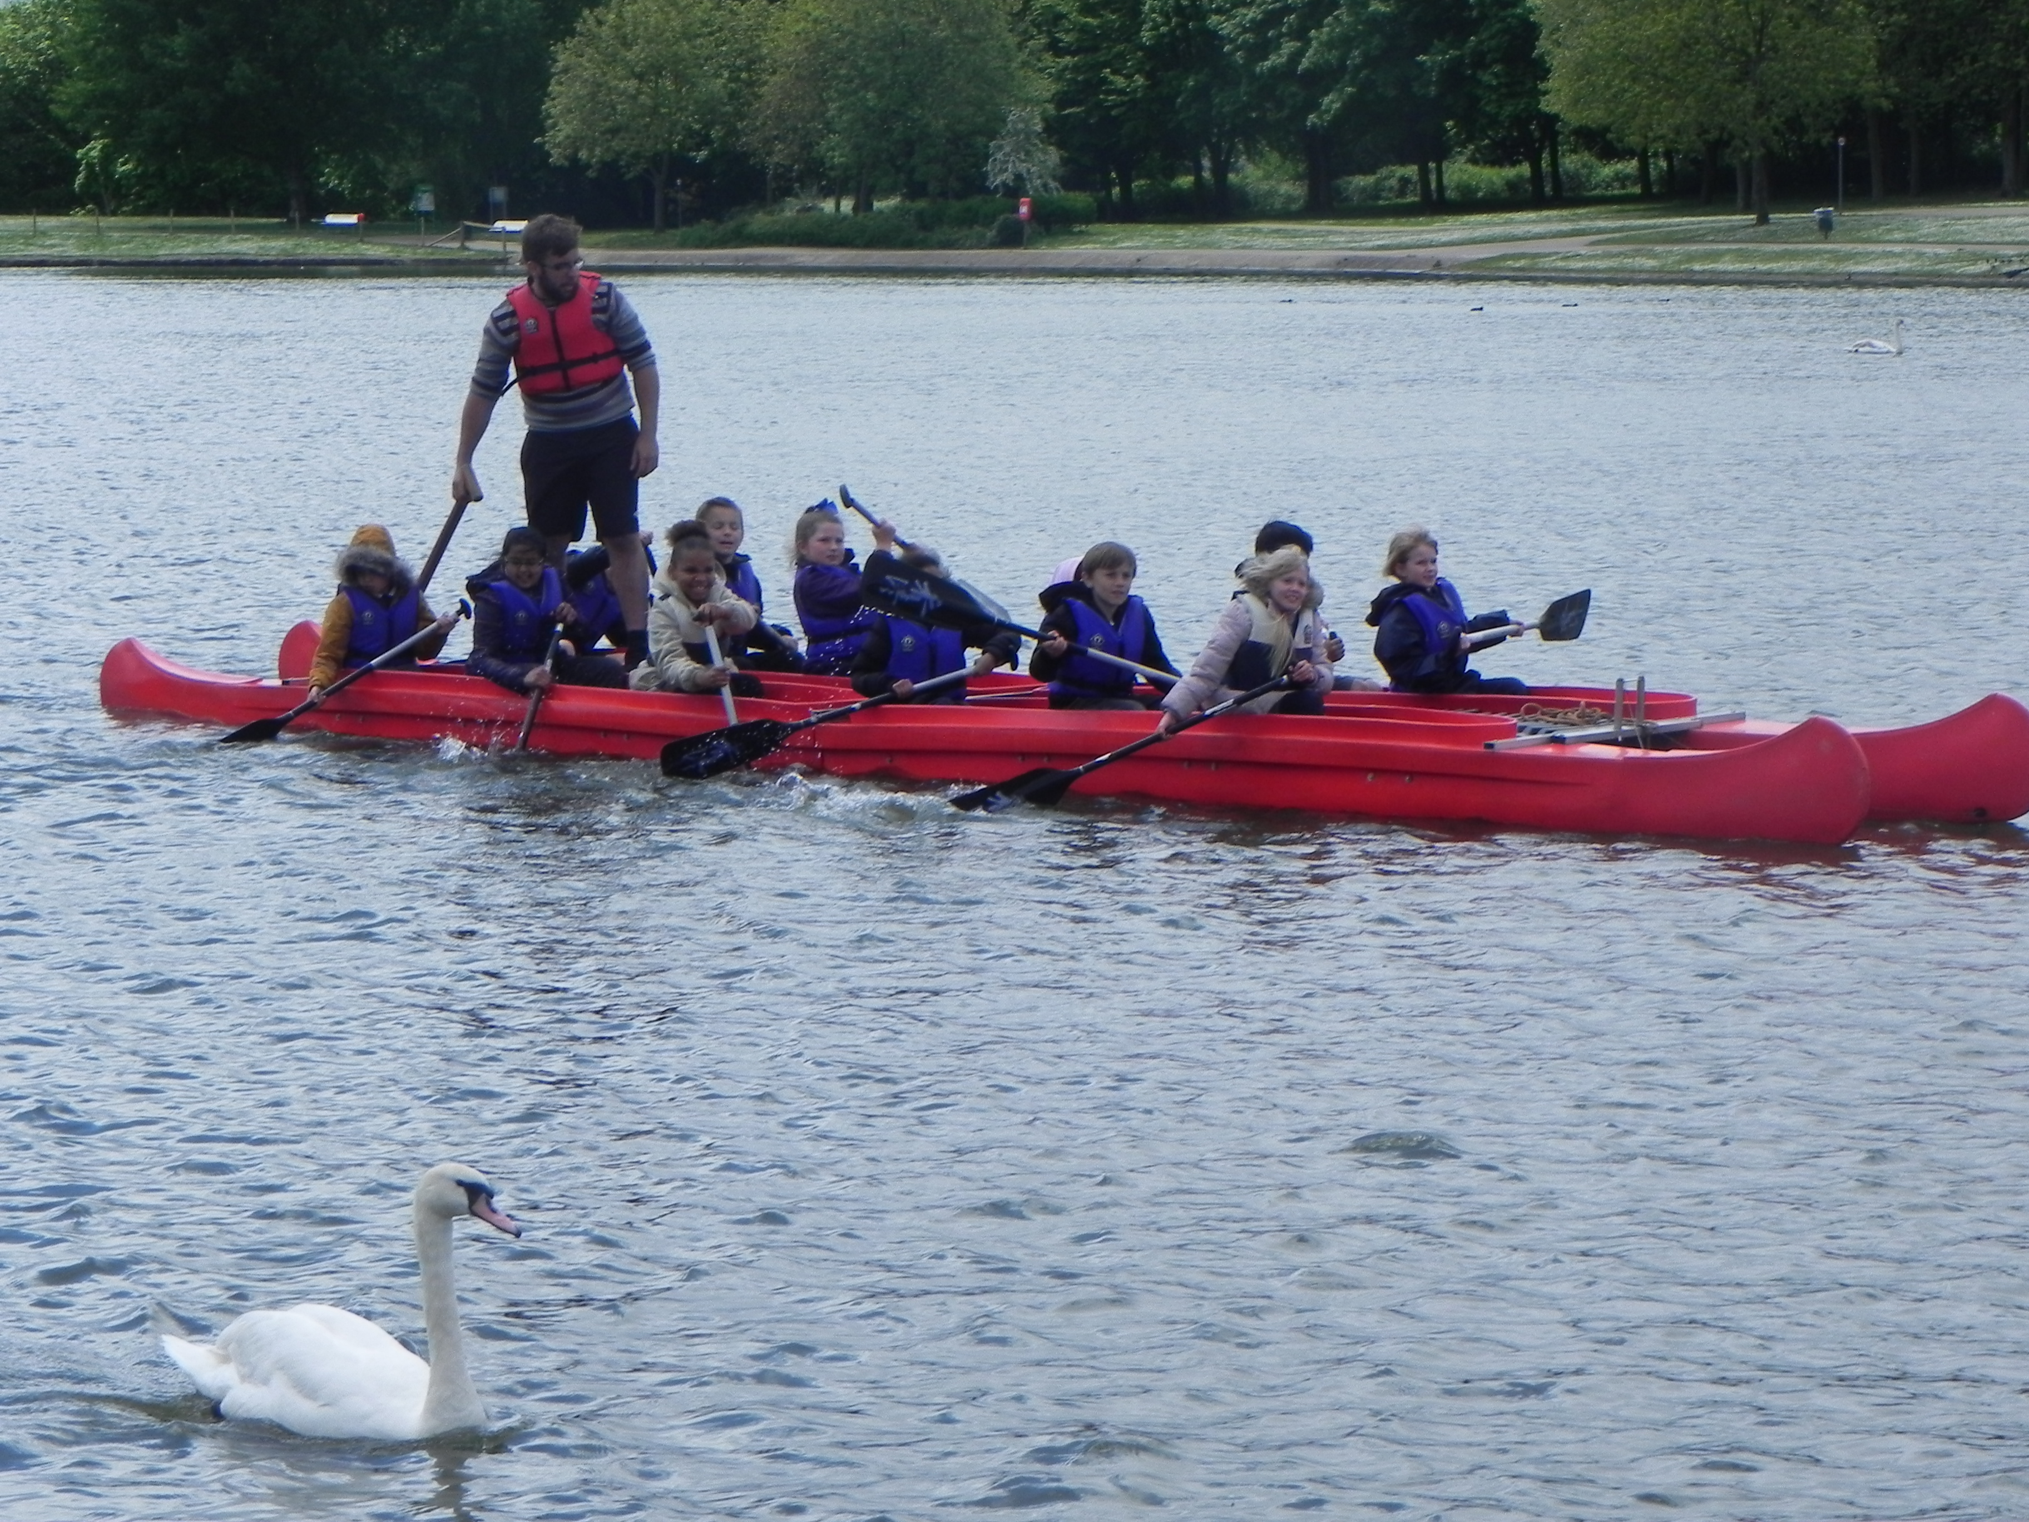
SG2 9SW

